**Chapter 5 - Chemical Kinetics**

**All Lectures Uploaded on YouTube:**

[**https://tinyurl.com/fkm10-chemistry**](https://tinyurl.com/fkm10-chemistry)



**Chemical Kinetics**

**Chemical Kinetics** is the study of:

* The **rates** (speeds) of chemical reactions.
* The **mechanisms** (steps) by which reactions occur.
* The **factors** that influence these rates.

Reaction rates vary greatly:

* **Slow:** Fermentation (weeks), Digestion.
* **Fast:** Acid-base neutralization (microseconds).
* **Moderate:** Muscle contraction, nerve impulses, photography.

**Importance:** Understanding kinetics is crucial for industry to make chemical processes **cost-effective**.

**5.1. Rates of Reactions**

The rate of a reaction tells us how quickly **reactants are consumed** or **products are formed** over time.It is defined as the **change in concentration** of a reactant or product per unit time.

**Mathematical Formula:**  
Rate = $\frac{Change in concentration of a substance}{Time taken for change}$

**Common Units:** moles per cubic decimeter per second (mol dm⁻³ s⁻¹).

**Graphical Representation (Concentration vs. Time)**

A typical graph shows two curves:

* **Reactant Curve:** Starts high and decreases over time.
* **Product Curve:** Starts at zero and increases over time.

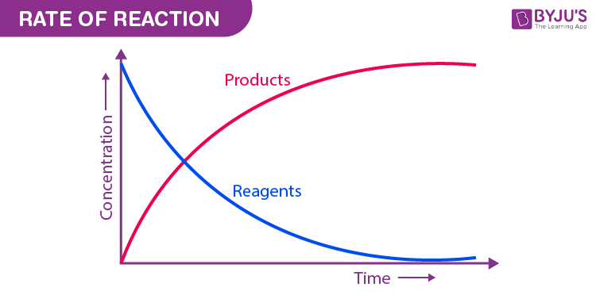

**Observations from the Graph:**

1. **Initial Stage (Steep Slope):**

At the start, the curves are steep. This means the reaction is **fast** because there are many reactant particles available to collide.

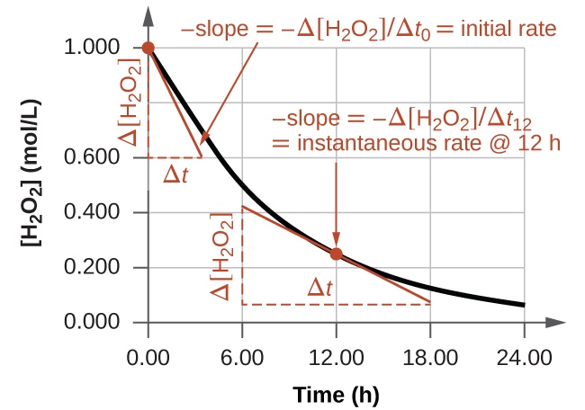

1. **As Time Progresses (Slope Decreases):**

The curves become less steep. The reaction **slows down** because the concentration of reactants decreases, leading to fewer successful collisions.

1. **Final Stage (Flat Curve):**

The curves become horizontal (flat).The reaction has **stopped** because the reactants are fully used up, or the system has reached **equilibrium**.

**Conclusion:** The rate of a reaction is **not constant**; it is highest at the start and decreases over time.

**Average Rate of Reaction**

This gives the overall speed of the reaction over a specific time interval.

**Formula:**   
Average rate = $\frac{Total change in concentration}{Total time taken}$

**Expressing Reaction Rate Mathematically**

For a simple reaction: **A → B**

* The rate can be expressed as the **disappearance of reactant A**:  
  Rate = - $\frac{d[A]}{dt}$

*(The negative sign shows concentration is decreasing)*

* Or as the **appearance of product B**:  
  Rate = + $\frac{d[B]}{dt}$

*(The positive sign shows concentration is increasing)*

Where d[A] and d[B] are the small changes in concentration, and dt is the small change in time.

**Interpreting Reaction Rate Data**

**Example Reaction: A + B → C**

The rate of this reaction can be followed by measuring the **concentration of the product (C)** at regular time intervals.

**Data Table & Analysis:**

| **Time(min)** | **Concentration of C (moldm⁻³)** | **Interpretation** |
| --- | --- | --- |
| 0.0 | 0.00 | Reaction has not yet started. |
| 20 | 15 | Product C is forming **rapidly**. The rate is high. |
| 40 | 21 | The increase in [C] is slower, indicating the **reaction is slowing down**. |
| 60 | 23 | The reaction continues to slow. Very little increase in [C]. |
| 80 | 25 | No further change in concentration. |
| 100 | 25 | The reaction has **stopped**; likely because a reactant has been used up. |

The data visually demonstrates that the **reaction rate decreases over time** as reactants are consumed.

**5.2. Collision Theory and Activation Energy**

Collision theory explains the requirements for a chemical reaction to occur at the molecular level.

**Two Conditions for a Successful Reaction**

For a collision between particles to result in a reaction, two criteria must be met:

* **Sufficient Energy:** Colliding particles must possess enough kinetic energy to overcome the repulsion between their electrons and break existing chemical bonds.
* **Correct Orientation:** The particles must collide in a specific spatial alignment that allows the atoms to rearrange and form new bonds.

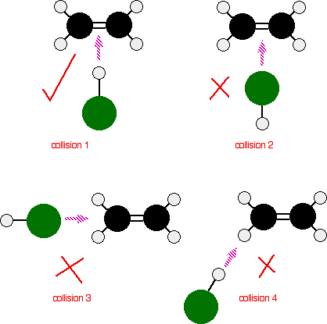

**Activation Energy (Eₐ):**

This is the **minimum amount of energy** required for a collision to be effective and lead to a reaction.

* **High Eₐ:** Fewer particles have this energy, so the reaction is slower.
* **Low Eₐ:** More particles have this energy, so the reaction is faster.

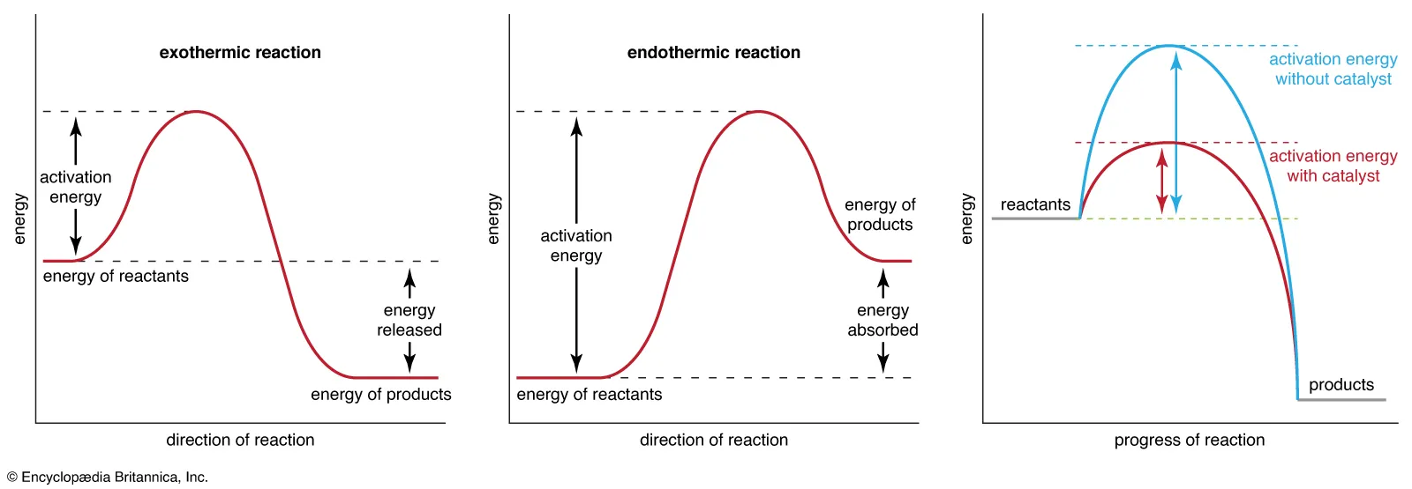

**Activated Complex (Transition State):**

* During an effective collision, particles form a temporary, high-energy, and unstable species called the **activated complex**.
* It is a transitional structure where old bonds are breaking and new bonds are beginning to form.
* It exists for a very short time before breaking apart to form the final products.

**Example: H₂ + Cl₂ → 2HCl**

1. **Reactants:** H₂ and Cl₂ molecules collide effectively.
2. **Activated Complex:** A high-energy arrangement (e.g., H--Cl--Cl) forms momentarily.
3. **Products:** The complex breaks down to form two stable HCl molecules

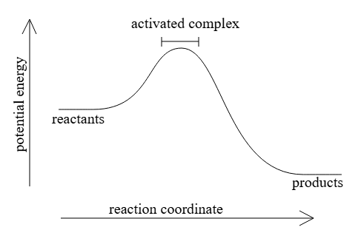

### 5.3. Catalysts and their Role in Reaction Kinetics

### A catalyst is a substance that speeds up a chemical reaction without being consumed or used up in the process.It provides an alternative pathway for the reaction that has a lower activation energy.

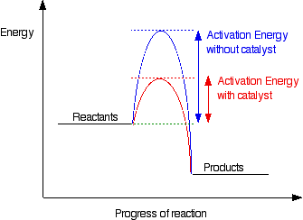

### How Does a Catalyst Work? (The "Hill" Analogy)

* **Without a Catalyst:** Reacting particles must overcome a high energy "hill" (the original activation energy). Few particles have enough energy, so the reaction is slow.
* **With a Catalyst:** The catalyst provides a different, **lower hill** (lower activation energy). This allows **more particles** to have the required energy to react, leading to a faster reaction.

#### Properties of Catalysts

* **Not Consumed:** A catalyst remains **unchanged in mass and composition** at the end of the reaction.
* **Does Not Initiate Reactions:** A catalyst **cannot** make a non-spontaneous reaction happen. It only speeds up a reaction that is already feasible.
* **No Overall Energy Change:** A catalyst does not alter the **total energy change** (ΔH) of the reaction between reactants and products.

**5.3.1. Physical Parameters that Affect the Rate of Reaction**

Several measurable physical changes indicate that a reaction is occurring and can be used to track its rate.

#### 1. Change in Mass

As reactants are used up, their **mass decreases**. As products are formed, their **mass increases**. Monitoring mass change over time is a direct way to measure the reaction rate.

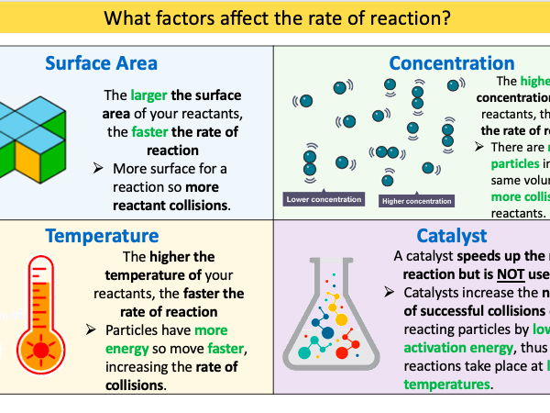

#### 2. Formation of a Gas

In an **open system**, if a gas is produced and escapes, the **mass of the reaction mixture will decrease**. In a **closed system**, the gas cannot escape. As more gas is produced, the **number of gas particles increases**, leading to an **increase in pressure** (if volume is constant). This pressure increase can be measured to track the rate.

#### 3. Temperature

**Increasing the temperature** increases the reaction rate. At higher temperatures, particles have **more kinetic energy**. They move faster, leading to more frequent collisions. A greater proportion of particles have energy equal to or greater than the activation energy, leading to more successful collision

### 5.3.2. Factors Affecting Rate of Reactions

**Several** factors influence the reaction rate by affecting the frequency and **effectiveness** of collisions between particles.

#### 1. Concentration of Reactants

#### Higher concentration leads to a faster reaction rate. More reactant particles in a given volume increase the frequency of collisions.

#### Examples:

* Stronger (higher H⁺ concentration) in acid rain damages marble faster.
* Two antacid tablets neutralize acid faster than one because more reacting particles are present.
* Doubling the concentration of H₂ or Cl₂ gas doubles the reaction rate.

#### 2. Surface Area (for Solids)

A larger surface area leads to a **faster reaction rate**. Breaking a solid into smaller pieces or powder exposes more particles to the other reactant, increasing the **number of sites where collisions can occur**.

**Examples:**

* Zinc powder reacts with dilute HCl faster than a zinc lump.
* Powdered aluminum reacts quickly with NaOH, while aluminum foil reacts slowly.

#### 3. Temperature

Higher temperature leads to a **much faster reaction rate**.

* **More Frequent Collisions:** Particles move faster, leading to more collisions per second.
* **More Energetic Collisions:** A greater proportion of particles have kinetic energy equal to or greater than the **activation energy (Eₐ)**.

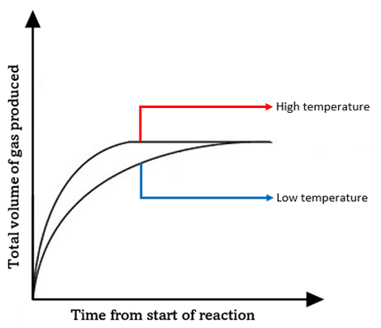

#### 4. Pressure (for Gaseous Reactions)

Higher pressure leads to a **faster reaction rate**.Increasing the pressure of a gas is equivalent to increasing its **concentration** in a given volume. This forces gas particles closer together, resulting in more frequent collisions.

**Example:** Doubling the partial pressure of H₂ or Cl₂ in their reaction mixture doubles the reaction rate.

### Maxwell-Boltzmann Energy Distribution

This concept explains *why* temperature has such a significant effect on reaction rate. The Maxwell-Boltzmann curve shows the distribution of kinetic energies among particles in a gas at a specific temperature. No particles have zero energy. Only a **small fraction** of particles have energy greater than or equal to the activation energy (Eₐ) at a given temperature (T₁).

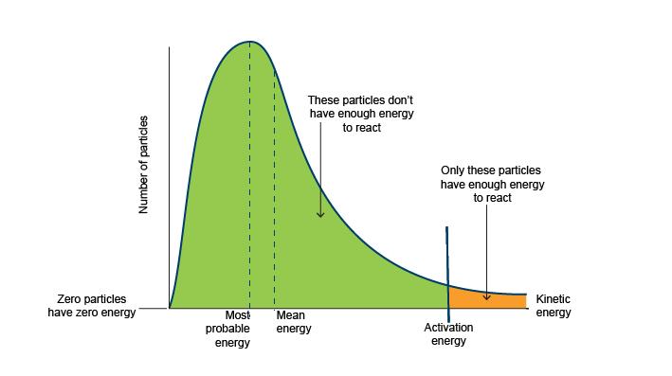

**Effect of Increasing Temperature (to**T₂**):**

The entire curve shifts to the right and flattens, meaning the **average particle energy increases**. Crucially, the area under the curve beyond the activation energy (Eₐ) **significantly increases**. This means a **much larger proportion of particles** now possess the required energy to react upon collision.

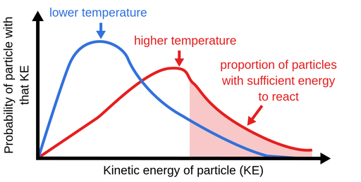

**Conclusion:** An increase in temperature doesn't just cause more collisions; it dramatically increases the number of **effective collisions** (those with energy ≥ Eₐ), which is the primary reason for the faster reaction rate.

**5.3.4. Enzymes**

Enzymes are **biochemical catalysts** that regulate the vast majority of chemical reactions within living organisms. **Nature:** They are specialized **proteins**.

**Properties:**

* **Not Consumed:** Like catalysts, they are not used up in the reactions they facilitate.
* **Highly Specific:** Each enzyme catalyzes **only one specific reaction**.
* **Extremely Efficient:** They can speed up reactions by a factor as high as **10²⁰**.
* **Location:** Found inside cells and in extracellular fluids (e.g., saliva, gastric juice).

**How They Work (Lock and Key Model):**

Enzymes have a specific three-dimensional shape. They bind to reactant molecules (substrates) and hold them in the **precise orientation** required for a successful collision. This precise binding dramatically **lowers the activation energy** and increases the reaction rate.

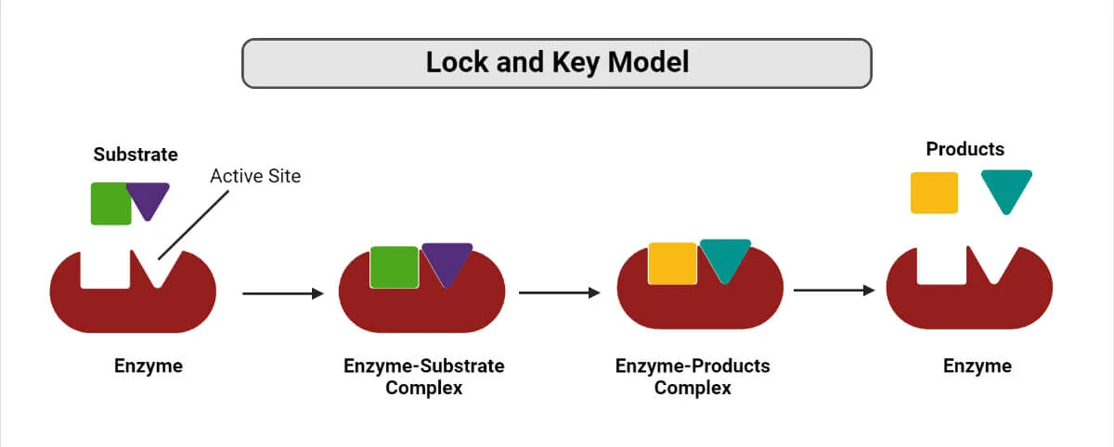

### 5.4. Role of Chemical Kinetics in the Food Industry

Chemical kinetics is applied in the food industry to control quality, minimize waste, and extend shelf life. Key applications include:

**Optimizing Harvest and Transport:** Determining the best time to harvest and transport produce to ensure it arrives with optimal taste, texture, and nutritional value.

**Minimizing Losses:** Estimating harvest time so products reach the market at peak quality, reducing losses from over-ripening during transit.

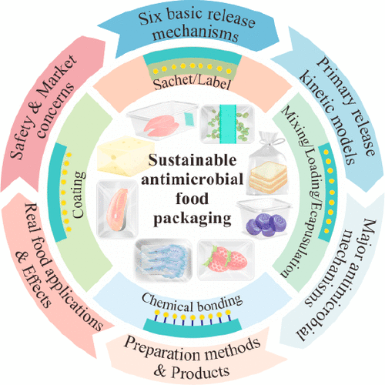

**Understanding Degradation:** Identifying factors (like oxidation) that cause food spoilage during transportation and storage.

**Improving Storage Methods:** Developing storage and transportation conditions (e.g., controlled atmospheres) that preserve nutritional content.

**Shelf Life:** Using kinetics to find methods (like refrigeration or modified packaging) that **slow down degradation reactions** by controlling temperature and humidity.

